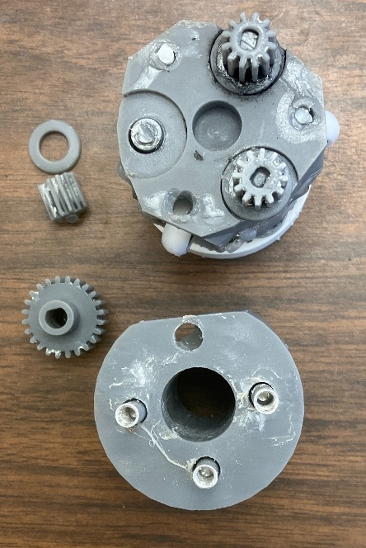
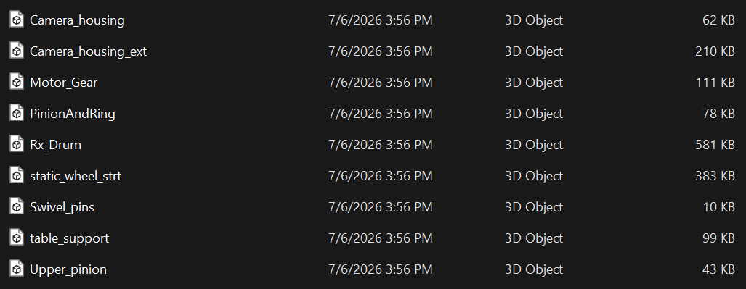
3-D Printed Parts
Camera Housing
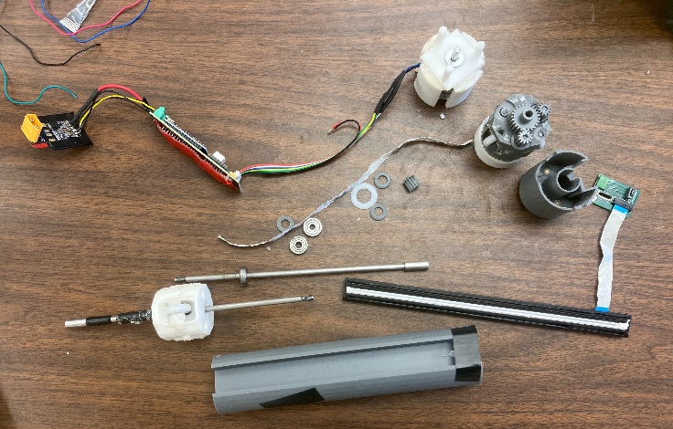
Camera Housing Ext (The smaller half)
Motor Gear
Pinion and Ring - 3
Drum
Static Wheel
Swivel Pins - 4
Table Support
Upper Pinion – 3
Plastic Washers – Printed with Pin
Motor Housing

Parts that Have to be Purchased/Salvaged
FFC cable
Scanner Head
Scanner Board
Motor
Metal Rods - 2
Ball Bearings – 2
Spacer Screws – 4
0.5mm Washers - 2
Clear Washer
Board components
Other Things Needed
WD-40 Between Pinions for smooth rotation. Along with electrical tape.

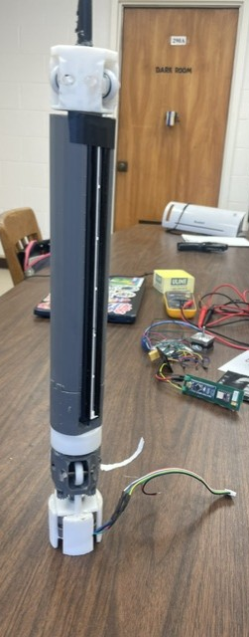
Assembly/Disassembly
Full Camera Prototype pictured left.
The top has Static Wheel and Wheels, glued in instead of using pins.
The middle is Camera Housing with Scanner Head taped in.
Under the camera housing is the Drum, and then the another Static wheel connecting to the motor with Pinions, upper and lower. The Pinions connect to the motor the Motor Gear, or sun.
On top of the motor is the Table Support, and then the motor is housed in motor housing?
It connects off-screen to a board, and another board that can connect to a battery.

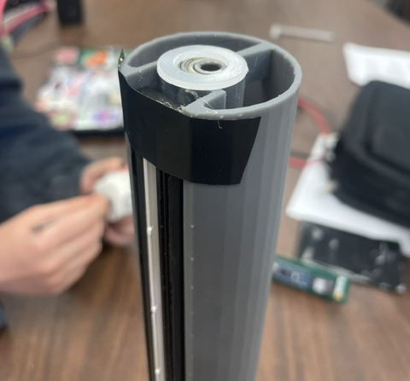
Clear Plastic Washer on top of Camera shell with Scanner head taped in.
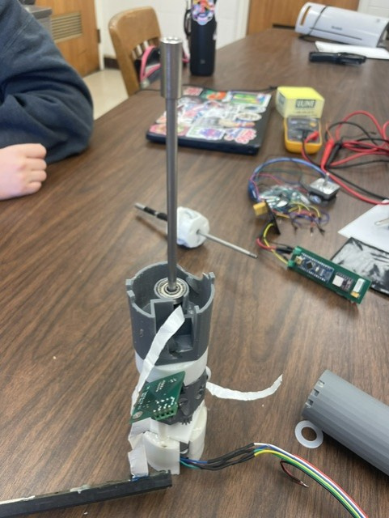
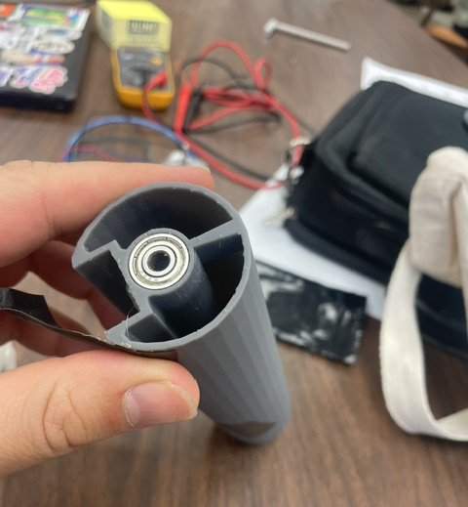
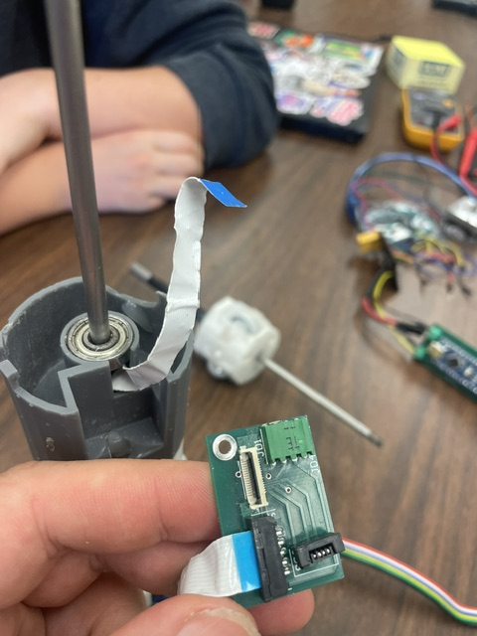
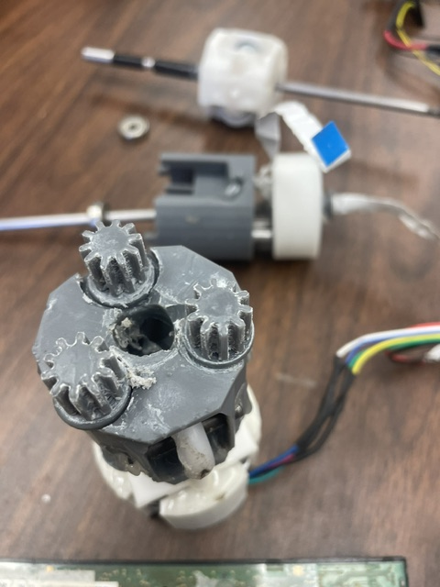
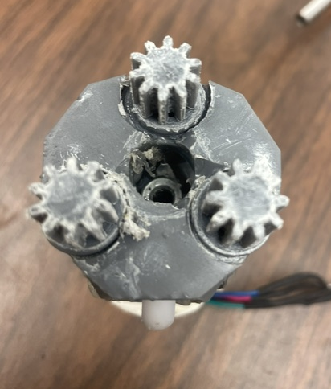
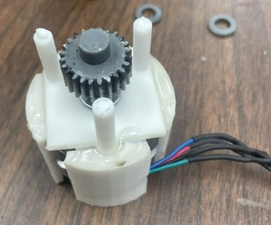
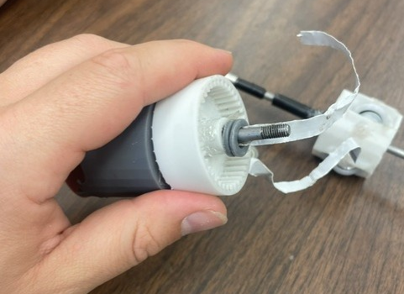

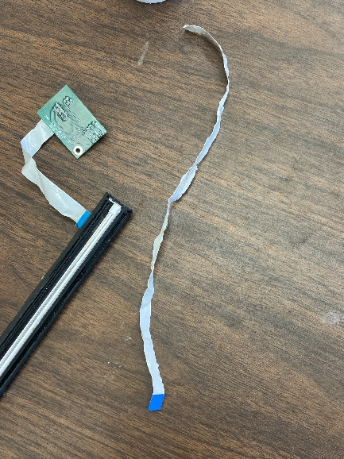
What’s the Thing Called and Where can We BUY IT?
FFC Cable, 15 pins
- Previously brought on Amazon.

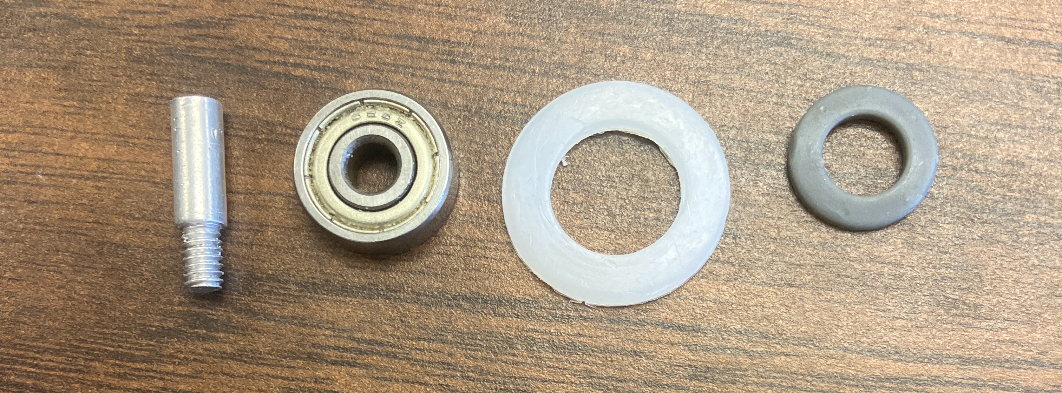
From left to right, Spacer Screw(1.5in/1.9cm), Ball Bearing, Clear Washer(1.3cmx2.2cm), 3-D print Washer(0.8cmx1.4cm).
Spacer Screws are available at Home Depot.

5mm Bore Bearing - 20mm White Plastic Tire, aka the Wheels, can be found here:
https://vxb.com/products/5mm-bore-bearing-with-20mm-white-plastic-tire-5x20?utm_source=google&utm_medium=organic&utm_campaign=Multifeeds&utm_content=5mm+Bore+Bearing+-+20mm+White+Plastic+Tire+5x20x5.5mm

